Course Syllabus
Edit
Spanish I CRN 13766 Download Spanish I CRN 13766 Courses SyllabusDownload Courses Syllabus

202410 Elementary Spanish I SPN-1120-13766
SPN 1120 Elementary Spanish I
CRN 13766
Fall 2023 (4 credits hours)
(Mixed mode course)
West Campus
Instructor: | Professor George Flores
Telephone: | 407-582-1048 Ext. 1300
Office: | West Campus
Office hours: | Monday (6:00 p.m.--7:40 p.m.)
E-mail: | Gflores5@valenciacollege.edu

Course Description: Prefix: SPN1120
This course requires self-discipline and time commitment. Students are expected to dedicate substantial time to study outside the time spent online in completing activities. The level of proficiency you attain will depend on you as the student. To be successful in this course you will need self-discipline, motivation, and time, you may want to consider the classroom setting instead. Keep up with the pace of the course and ask for help as soon as you feel you need it.
Final Exam:
Monday August 21, 2022 (6:00 p.m-7:40 p.m.)
---------------------------------------------------------------------------------------------------------------- * This syllabus is a contract between the student and the instructor. By enrolling in and then attending this course, the student agrees to and accepts the terms and conditions of this contract. It is the responsibility of the student to carefully read this syllabus/contract in its entirety and to adhere to all policies and procedures within the syllabus.
------------------------------------------------------------------------------------------------------------------
Correspondence with the Instructor:
- This is Mixed-mode course; therefore, it is also extremely important that you learn how to communicate virtually. All correspondence with the professor must be done through Canvas or through your Valencia email address (Atlas). Any emails sent to
- the professor with ‘Gmail’, ‘Yahoo’ or any other external email address will not be answered. E-mail will be an integral part of this course.
- You must check your ATLAS emails often (2 to 3 times a week) and only email me through Atlas/Outlook/Canvas. Also, use the e-mail tool (Messages) inside Canvas. Do not use personal emails. You will not receive any response. When sending an email, include your CRN in the subject line followed by the nature of your message so that your email will have priority. I will answer all emails and/or phone calls in a timely fashion. In most cases, you should expect my reply within a 24-hr. period, excluding Saturdays and Sundays (unless there is an emergency).
- When you receive any email from me that requires your response, I expect you to reply in a timely fashion as well. Not checking emails will not be accepted as an excuse for missing required assignments and other tasks. Do not email me an hour before an assignment is due with concerns over technological issues and expect a response or resolution in time for you to complete that assignment. Plan ahead and expect that there may be a technology issue (because sometimes these things happen!) and allow yourself time to get it resolved before the due date and time.
- To protect my computer from any virus, I will delete without opening any email with no subject. All communications should follow appropriate etiquette. Email should be used in a professional way. Always put identifying information in the subject line so that I know what your message is about.

REQUIRED TEXT:
- Blanco (2022) Portales 2.0: Introductory Spanish. Vista Higher Learning
It is recommended that you purchase the textbook at the Valencia Bookstore. By doing so, you are guaranteed to receive the book and the online access that is required for the course. If you purchase the book online from an outside vendor such as Amazon, you are not guaranteed to receive the book and online access that is required for this course. Two ways to purchase.
Portales 2.0 Code (v Text) (12Month Access)
ISBN: 978-1-54336-829-1 (Student Edition)
====================================================================
Portales 2.0 Loose-leaf + code (v Text) and online (12-Month Access)

ISBN: 978-1-54337-437-7 (Student Edition)

Digital access
Portales 2.0 (vText) Digital access only 24 Month Access
ISBN: 978-1-54336-828-4
TEXTBOOK
There are two ways to purchase your textbook
1) Go to https://www.valenciabookstores.com/
2) Go to https://vistahigherlearning.com/school/valenciacollege
* Create username and password
* Click Spanish
* Click Spanish 1120/1121
* Your cheapest option is Digital format for 12 months
Can’t purchase your book right away?
It is imperative that you purchase the textbook right away so this will give you access to the online platform where you will be doing many of your activities.
In the event that you cannot purchase your textbook right away, you can still go to www.vhlcentral.com (this is the textbook website where you will be doing the activities), create your username and password, and enroll in the course. I will see your name and can give you a temporary two-week access so that you do not fall behind.

See the link below for detailed instructions on registering in the textbook online platform (VHL)
https://www.vhlcentral.com/section/32d5f7aa-d9ae-4c07-a6c1-139304b97ab8/student_instructions

Optional and/or recommended:
- Spanish –English dictionary, (Cuyás, Collins, Larousse, Oxford, or Vox).
- English Grammar for Students of Spanish: The Study Guide for Those Learning Spanish (English Grammar Series); Spinelli
- 501 Spanish Verbs; Kendris

ON-LINE REQUIREMENTS AND PROFICIENCIES:
Internet browsing, file management, typing and word processor editing. A computer with camera and microphone will be required for this course. If you have difficulty obtaining the proper computer equipment you may use the following computer labs:

- West Campus: Computer Access Lab 6-101 (located inside the library)
- East Campus: Language Lab 4-104 ( located inside the library)
- Osceola Campus: Library lab 1-131
- Winter Park: Library 140
COURSE DESCRIPTION:
For students without two years of recent high school Spanish completed within the last three years or department approval. The class will emphasize everyday use of the language, integrating basic grammar, vocabulary, composition, and culture through a conversational approach to Spanish. This class is not open to native or heritage or native speakers. A minimum grade of “C” is required if being used to satisfy the General Education Foreign Language proficiency requirement. Four credits will be earned upon successful completion of this course.
This class is not open to native or heritage speakers. Please see definition of Native and Heritage Speakers on the last two pages of the syllabus.

COURSE OBJECTIVES:
The objective is for students to achieve a novice level of proficiency in the target language (in writing, speaking, reading, and listening) as well as awareness of the Hispanic culture. In addition to competencies at the end of the semester you will be expected to be able to use the target language at an intermediate/ novice level.

LEARNING OUTCOMES:
Student will be able to communicate verbally and orthographically in the target language at an intermediate/mid-level according to the American Council of Teaching of Foreign Languages (ACTFL) as well as develop listening and reading skills in the target language at an intermediate/mid proficiency level according to ACTFL. Furthermore, students will develop a mature attitude towards cultural differences.
Attendance:
Regularity in classroom attendance is mandatory and vital to academic success. Students who do not maintain regular attendance are subject to lose 5 % of your grade.

WITHDRAWAL POLICY
- Per Valencia Policy 4-07 (Academic Progress, Course Attendance and Grades, and Withdrawals), a student who withdraws from class before the established deadline for a particular term will receive a grade of “W”.

- A student may withdraw at any time during the term in Atlas up until the withdrawal deadline of 10/27/2023.

- After the withdrawal deadline, students can no longer withdraw themselves

- Any student knowing that he/she is not going to pass the course stops coming to class will receive an F for the course unless he/she withdraws himself before the withdrawal date of 10/27/2023.

- Withdrawing from a course is the student’s decision. The professor may recommend to drop or stay in the course however by making these statements is by no means guaranteeing a passing or failing grade.

- The professor will not withdraw a student at any time (some exceptions apply) .

HONORLOCK
https://drive.google.com/file/d/1acsXYiELWBToCYXFWkCVPdhvg9cthN8e/view?usp=sharing
Proctored Exam Requirement
This course utilizes Honorlock, an online exam proctoring service, to promote academic integrity during online testing. You do not need to create an account, download software, or schedule an appointment in advance. Honorlock is available 24/7. After you verify your identity and scan your room, you can begin your exam. Honorlock will record you via webcam, as well as record your screen activity. Honorlock’s system also includes a process that can detect inappropriate search-engine use, while protecting the privacy of your personal information. The recorded information will be subject to the protection of the College’s policy on Student Records.
To take an online exam, you will need:
- A laptop or desktop computer with a microphone (not a tablet or phone)
- A webcam
- Reliable Internet connection
- Photo identification in the form of a Valencia-issued student ID card or government-issued ID card (i.e. driver’s license, passport)
- Google Chrome downloaded (required browser)
- Honorlock Chrome Extension downloaded
Honorlock support is available 24/7/365. Support access is built into Honorlock in real-time.
If you encounter any issues during an exam, you can contact support by live chat within the Honorlock window in Canvas, by phone (855-828-4004), and/or by email at support@honorlock.com. For answers to common questions on online proctoring, visit the Student FAQLinks to an external site. page or Honorlock’s student information website .
Valencia has a contract with Honorlock that requires Honorlock to be FERPA compliant and to use securely encrypted protocols to save and view all test taker assets. Honorlock may only collect, process, and store student data for contracted services and this information cannot be sold or transferred for any purpose. Honorlock's certified proctors and your institution's faculty are able to review test session videos until deleted based on the school's retention policy. See the Honorlock Security and Honorlock Privacy Statement.
Click here for full explanation of Honorlock click here on how to scan a room in Honorlock https://www.youtube.com/watch?v=ISz-ZIVfxkc&feature=youtu.be

NATIVE SPEAKERS AND HERITAGE LEARNERS
SPN 1120 (Elementary Spanish I), SPN 1121 (Elementary Spanish II), SPN 1000 (Conversational Spanish I), SPN 1001 (Conversational Spanish II) are classes specifically designed for non-native speakers or non-heritage learners. If you are a native speaker or heritage learner, this class is not for you.
A native speaker is one who was born and raised in a Spanish-speaking country and has studied the language formerly in elementary school and/or high school in a Spanish speaking country.
A heritage learner is one who was born in the United States or moved to the United States from a Spanish-speaking country at a very young age, has never formerly studied the language, but speaks/spoke Spanish at home. A heritage learner can communicate orally with a limited vocabulary but has not fully developed writing or reading skills. In addition, proper sentence formation, correct grammatical usage, and good pronunciation are usually lacking in their conversation.
In short, “a student who is raised in a home where a non-English language is spoken, who speaks or merely understand the heritage language and who is to some degree bilingual in English and the Heritage language” (Valdes, 2000)
If you are a native speaker, this class is not for you. It is strongly encouraged that you take another language class such as Portuguese, French, German or Latin. Another option is to take the CLEP (College Level Examination Program) Test which awards college credit for demonstrating achievement in a subject by means of a computer-based exam.
If you are a Heritage learner, Valencia has created a course for you that will count as Foreign Language credit. This course is called Spanish for Heritage Speakers I and II (SPN 1340 and SPN 1341). These classes are designed for students who have some level of fluency but wish to become more fluent, become better readers in Spanish and become better at expressing themselves orally and in written form in Spanish all while improving their vocabulary and grammar. To both Native Speakers and Heritage Learners: You are strongly encouraged to drop this course. If you do not and it is discovered later on that you are indeed a Heritage Learner, it will leave you little or no time to register for another course or take the CLEP. https://valenciacollege.edu/students/assessments/clep.php
For Elementary language courses, we don’t allow students to use any elements of the language that we are not specifically learning in the class. Why is this? Because this is a good indication that somebody else is doing their work for them or they are using an online translator. If this happens, they receive a very low grade or a zero. For students that have some level of fluency (Native speakers or Heritage learners), it is inevitable that they use elements of the language that is not in our learning parameters. They as well, receive a low grade or a zero. As a result, in order to get a good grade, Native speakers and Heritage Learners feel forced to use a level of the language that is lower than their level of proficiency. As a result, no real learning is taking place. For this reason, we offer many other languages or Spanish for Heritage Speakers.
- Last day to Refund/drop is 08/28/2023

TWO WEBSITES
This Mixed mode Spanish course will utilize TWO websites. We will be using Canvas and Supersite. The online component of our textbook is called the Supersite.
You will be using Canvas for the following:
- Keeping track of your grade
- Taking exams
- Participating in discussions
- Doing online presentations
- Seeing what assignments are due and when.
- Doing assignments not included in the Supersite
- Receiving extra materials such as worksheets, PowerPoints, useful YouTube and other helpful links
- Communication between professor and student
You will be using the Supersite for the following:
- Viewing tutorials
- Seeing what Supersite assignments are due and when
- Doing Supersite activities (Written homework/Virtual Chat)

When you purchase the access code at the Valencia Bookstore, you will receive a code that will give you access to the Supersite. The following link gives you instructions on how to register.
https://www.vhlcentral.com/section/32d5f7aa-d9ae-4c07-a6c1-139304b97ab8/student_instructions
Method of Instruction:
This is Mixed Mode course. Some of our learning activities will be in class and some will be online. Some online activities are homework and others are learning. The course will be taught through a combination of lecture in-person, online Supersite, and Canvas modules. The chapter tests, quizzes and homework will be turned-in according to the schedule outline in the course calendar. Each test, quiz, and oral presentation is time and starts at the beginning of the lecture class; late students will not be given extra time to complete assessment.
In-person lecture:
- There are sixteen F2F meeting. We will be held on Wednesday Building 1; Room # 132. Tests and quizzes will be scheduled to take online, in the classroom, or Valencia Testing Center when is necessary.
- There is one cumulative departmental final exam at the end of the semester. This test will be in-person and will have 100 multiple choice questions to be answered in 2 hours 30 minutes.
- The lecture quizzes will be online (Canvas). These will assess students’ conceptual understanding and will be scheduled with the course calendar.
- There will be four-chapter test (online or in class).

Online lecture:
* All online assessments are through “Canvas modules”, Supersite, and Atlas email.
- Spanish course homework assignment (Supersite) will have 10 points. Students will have additional attempts after the due date for practice. These assignments are learning centric interactive activity-based assignments, and students are required to have an adequate computer system available for them to work.
- These assignments (com) are composed of critical thinking. The activities will include extensive grammar-driven practice, vocabulary practice, listening practice, oral communication activities, reading activities as well as activities to develop your oral proficiency.
- Students will have access to “study modules” for all the chapters (Canvas), for study purpose through-out the semester.
- Please note that Canvas takes time to sync with mastering Spanish grade, so after you submit the assignment, it may take ~2 hours for the grade to be updated completely on Canvas.
- It is the students’ responsibility to complete the online assessments before the due date and time as per the course calendar. Under no-circumstances, grace time will be provided.

Grading: Your grade will be calculated as follows for each course.
Supersite activities (VHL) Homework and Virtual Chat-------------------------15%
Speaking assess/language disc (Final speaking project)--------------------------15%
Chapter exams------------------------------------------------------------------------15%
Quizzes --------------- ----------------------------------------------------------------10%
Cultural paper--------------------------------------------------------------------------5%
Midterm speaking -------------------------------------------------------------=------5%
Journals (1-5)---------------------------------------------------------------------------5%
Class attendance ----------------------------------------------------------------------5%
Final Exam----------------------------------------------------------------------------- 25%
GRADING: Your grade will be calculated as follows:
90-100 | A
80-89 | B
70-79 | C
60-69 | D
59 - 0 | F
Exams
- Throughout the course you will have chapter exams in class and in Canvas.
- The exams/quizzes will consist of listening, reading comprehension, grammatical knowledge, writing and cultural competence
- The writing portion of the exam will be assigned separately. In other words, you will have two assessments for each chapter
- You will typically have a 2-4-day window to complete exams.
- Exams will have a time limit
- You will be able to see one question at a time and you will not be permitted to backtrack.
- Once you open the exam, you must complete it. You cannot close the exam and then reopen it later.
- There will be NO MAKE-UP EXAMS regardless of excuse.
- If there is any indication whatsoever that someone else is taking the exam for you, you will receive a Zero for the exam. Indications include, advanced vocabulary, advanced sentence structure, advanced verbal usage, slang, common errors made by native speakers. See section of plagiarism.
- It is your responsibility to have a working computer with reliable internet.
- There will be 3-chapter exams.
- There will be several quizzes (online).

Speaking assess/language disc/virtual chats
Speaking activities
This grading criteria is made up of various components:
1) Language (oral) - You will be asked to do oral presentations in this course through Zoom or in class. These presentations must comply with the minimum time requirement. If it looks like you are reading it will not be accepted. Feel free to use visuals to enhance your presentation. For example, if you are saying that you like to play soccer, hold up a soccer ball.
2) Language (writing) - You will be asked a question in Spanish. Then you will respond by posting a to at least two of your classmates' posts. Make sure you read the instructions for each discussion activity. These will be done in Canvas.
Remember to only use grammar and vocab that we are learning in class. By using advanced grammar and vocabulary, it will look like you are not doing your own work which will result in very low grade or perhaps a zero (up to professor's discretion).

- Midterm
The midterm will be a speaking assessment where you will speak with the professor in class or via Zoom (the professor will send you a Zoom invitation so that you can prepare).

- Included in these criteria are Virtual Chats:
Virtual chats are activities in the Supersite. They include an Avatar that will ask you questions. You are supposed to orally answer these questions in a complete sentence. Within each Virtual Chat Activity, I have added to the instructions, the page and activity number where you can see the questions before beginning the activity. This will allow you to prepare your answers before opening the activity in the Supersite. Remember that the Virtual Chat activities are part of your 'speaking' grade. They usually take a little longer to do than the typical multiple choice or fill in the blank so therefore I highlight when they are due here on the module pages so that you can plan accordingly. You can also go to "Calendar" in the Supersite to see when the Virtual chats are due.
Quizzes and Journals
Quizzes: There are several quizzes assigned per chapter. They are short quizzes that vary between fill in the blank and multiple choice. Their purpose is to make sure you are learning and understanding the material. You will have 3 attempts and there is no time limit.
Journals are done in Canvas. These are essentially practice writing assignments in which you will write on various topics. You are expected to use the material, grammar, vocabulary, and sentence structure that we are learning in the class. Any work that uses language that is beyond our scope of learning will receive a zero.
Homework in Supersite
The supersite can be found at VHLCentral.com. This is the online component of the textbook where you will do many of the activities of the course and keep track of your grade. The assigned activities will be listed in the calendar of the website. The activities will include extensive grammar-driven practice, vocabulary practice, listening practice, oral communication activities, reading activities, as well as activities to develop your oral and writing proficiency (journals). These activities will assist the student in internalizing the material they have learned. Homework will be completed on the dates that appear in the calendar in VHLCentral.com. There will be homework most days of the week. This is to ensure that you are staying in touch with the course on a daily basis.
For further instruction with the Supersite, please refer to this link.
https://www.vhlcentral.com/section/32d5f7aa-d9ae-4c07-a6c1-139304b97ab8/student_instructions

Some things to remember in regard to the Supersite
- The professor will not remind you every day to do your homework.
- You may submit assignments late. This will result in a 10% deduction per every day that it is late.
- In other words, please be responsible and manage your time wisely. Make sure you have a working computer. Remember, there are computer labs on all Valencia Campuses that are available to you the student.
- Please read the instructions to all activities!
Cultural paper
I will assign you a cultural topic, and you will have the chance to do a written paper related to the Spanish-speaking world. These will be done in English or Spanish (bonus). You will submit your answer via Canvas.
Midterm Exam SPEAKING
- The midterm speaking assessment will be given in the middle of chapter 3.
- The exam will be available in the classroom.
- The professor will ask you questions based on what we have learned in the class.
- This speaking assessment will take approximately 3-5 minutes.

FINAL EXAM will cover chapters 1-5 and is composed of 3 parts
- The 3 parts are: main part (vocab, listening, reading, grammar), writing, speaking.
- Students who do not take all 3 components of the final exam will not pass.
- The Final Exam DOES NOT have to be taken in the Testing Center
- If there is any indication whatsoever that someone else is taking the exam for you, you will receive a Zero for the exam. Indications include, advanced vocabulary, advanced sentence structure, advanced verbal usage, slang, common errors made by native speakers.
- The main part AND the “Writing” portion of the final exam will be available on December 04th.
  - The final speaking assessment will be done with the professor via Zoom. The professor will ask you questions based on your topic. This oral assessment will be available on XXXXXXXXXX
  - Students who do not take all component of the final exam (12/04/23) in class will not pass the class.
ACADEMIC HONESTY:
Student Conduct and Academic Honesty: Each student is required to follow Valencia policy regarding academic honesty. All work submitted by students is expected to be the result of the student’s individual thoughts, research, and self-expression unless the assignment specifically states, “group project.” Any act of academic dishonesty will be handled in accordance with Valencia policy as set forth in the Student Handbook and Catalog.
VCC Expected student conduct: 10-03 Student Code of Conduct
Specific Authority: 1006.60, FS.
Law Implemented: 1006.60, FS.

Valencia College is dedicated to the advancement of knowledge and learning, and to the development of responsible personal and social conduct. By enrolling at Valencia, a student assumes the responsibility for knowing and abiding by the rules of appropriate behavior as articulated in the Student Code of Conduct. The primary responsibility for managing the classroom environment rests with the faculty. Faculty may direct students who engage in inappropriate behavior that results in disruption of a class to leave the class. Such students may be subject to other disciplinary action which may include a warning, withdrawal from class, probation, suspension, or expulsion from the college. Please read the Student Code of Conduct in the current Valencia Student Handbook.
Here is the link to Valencia’s Student Code of Conduct website: http://www.valenciacollege.edu/policies/policydetail2.cfm?PolicyCatID=10&PolicyID=3
Exams and homework are considered individual effort; any submissions that are too similar for coincidence will receive no credit. Any submission that appears to have been done by somebody else (i.e., a native speaker, google translate) will be considered plagiarism and will receive no credit.
Students may collaborate in group assignments. Collaboration should be used to edit or to clarify doubts. If anyone is involved in incidents of cheating a zero will be given. Each student is expected to be in complete compliance with the college policy on Academic Honesty as set forth in the admissions catalog and the student handbook. Any student(s) cheating on an exam will receive a zero on the exam. This cannot be replaced with the final score and the professor at his/her discretion can withdraw you from the class or give you an F as a Final Grade.
Please see more information on Plagiarism at the following website:
http://valenciacollege.edu/west/arts-and-humanities/writing/plagiarism.cfm
Plagiarism
Guidelines to prevent copying from native speakers or online translators:
Only allow content that pertains to the class.
If it is suspected that you are using an online translator or a native or heritage speaker is doing your work for you, you will receive a zero on your assignment.
Most of the time it is obvious when you are not doing your own work; especially in your writing assignments and short answer assignments. By use of verb tenses that we are not learning, sentence structure that we are not learning, slang, and advanced vocabulary. Only use what we are doing in class. In doing so, I can be fairly certain that you are doing your own work. The aforementioned statement refers to exams as well.
Important course information!
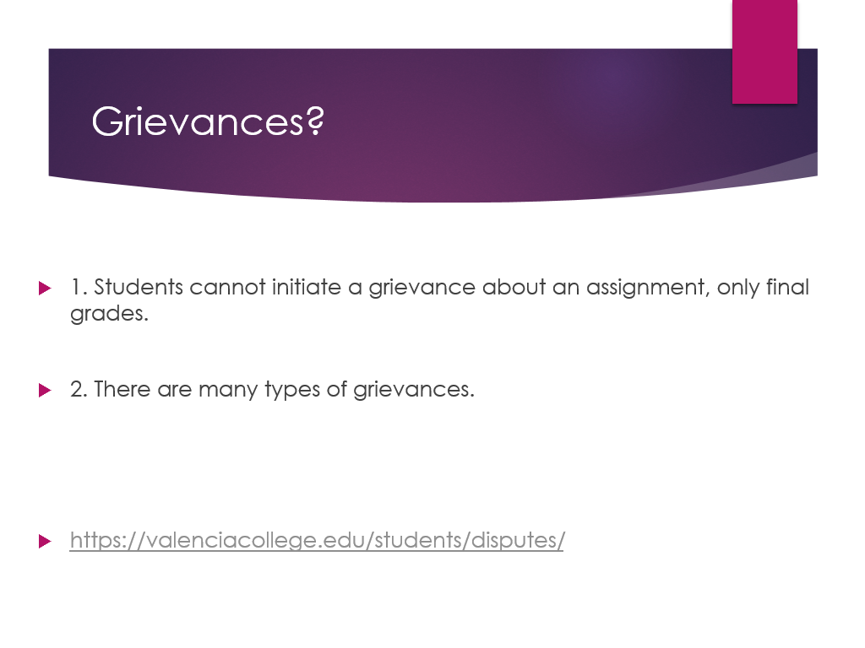
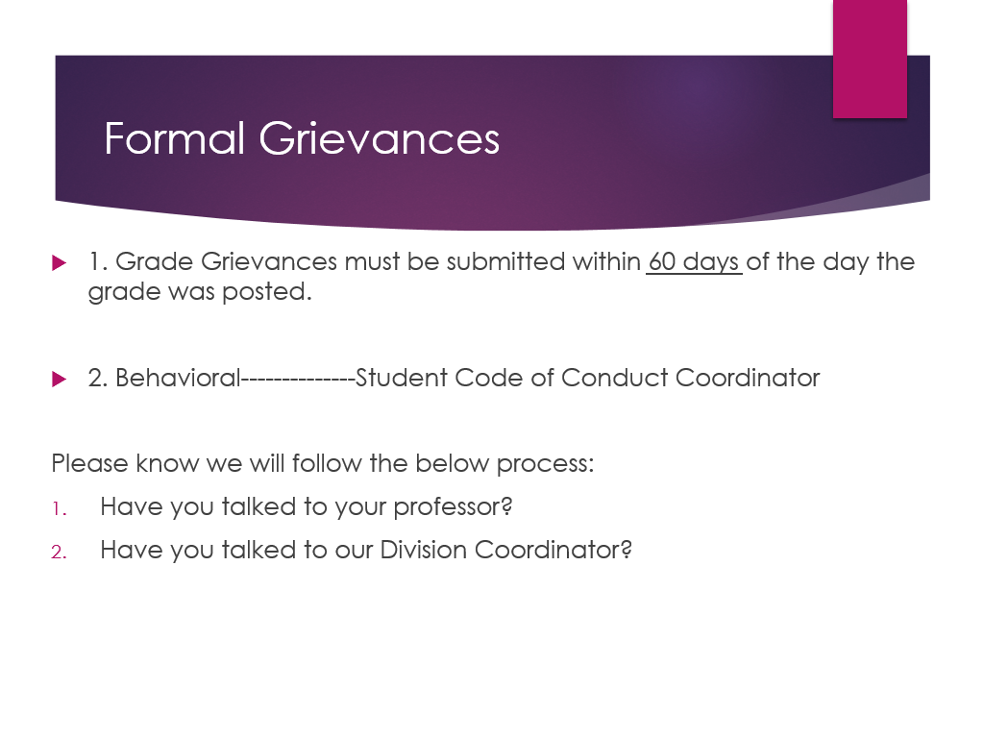
Plagiarism
The use of AI-generated responses and essays is strictly prohibited in this course unless otherwise explicitly approved by your instructor. AI includes “any kind of artificial computational system that employs complex behavior…used to satisfy the Learning Outcomes of a course or lesson” (Vincent C. Muller). ChatGPT, for instance, is an AI. Any assignment in violation of this policy will receive the punishments as specified in the Academic Dishonesty/Plagiarism policy.
Only allow content that pertains to the class.

I expect you to generate your own work in this class. When you submit any kind of work (including projects, exams, quizzes, or discussions), you are asserting that you have generated and written the text unless you indicate otherwise by the use of quotation marks and proper attribution for the source. Submitting content that has been generated by someone other than you, or was created or assisted by a computer application or tool, including artificial intelligence (AI) tools such as ChatGPT is cheating and constitutes a violation of the Student Conduct Code. You may use simple word processing tools to update spelling and grammar in your assignments, but you may not use AI tools to draft your work, even if you edit, revise, or paraphrase it. There may be opportunities for you to use AI tools in this class. Where they exist, I will clearly specify when and in what capacity it is permissible for you to use these tools.

If it is suspected that you are using an online translator or a native or heritage speaker is doing your work for you, you will receive a zero on your assignment.

Most of the time it is obvious when you are not doing your own work; especially in your writing assignments and short answer assignments. By use of verb tenses that we are not learning, sentence structure that we are not learning, slang, and advanced vocabulary. Only use what we are doing in class. In doing so, I can be fairly certain that you are doing your own work. The aforementioned statement refers to exams as well.

http://valenciacollege.edu/west/arts-and-humanities/writing/plagiarism.cfm

Valencia College Expected student conduct: 10-03 Student Code of Conduct
Valencia Community College is dedicated to the advancement of knowledge and learning, and to the development of responsible personal and social conduct. By enrolling at Valencia, a student assumes the responsibility for knowing and abiding by the rules of appropriate behavior as articulated in the Student Code of Conduct. The primary responsibility for managing the classroom environment rests with the faculty. Faculty may direct students who engage in inappropriate behavior that results in disruption of a class to leave the class. Such students may be subject to other disciplinary action which may include a warning, withdrawal from class, probation, suspension, or expulsion from the college. Please read the Student Code of Conduct in the current Valencia Student Handbook.
Here is the link to Valencia’s Student Code of Conduct website:
http://www.valenciacc.edu/policies/policydetail2.cfm?PolicyCatID=10&PolicyID=3

Returning to Campus
https://valenciacollege.edu/about/coronavirus/

Valencia Returning to Campus Policies
o Valencia Reporting and Contact Tracing
https://valenciacollege.edu/about/coronavirus/illness-reporting-and-contact-tracing.php
Questions About Roadmap for Reopening Phase 4? Get the Answers
http://thegrove.valenciacollege.edu/questions-about-roadmap-for-reopening-phase-4-get-the-answers/

Roadmap for Reopening: Phase 4 Hours of Operation
http://thegrove.valenciacollege.edu/roadmap-for-reopening-phase-4-hours-of-operation/

Contact Tanya Mahan if you become ill with COVID-like symptoms, test positive, or come in contact with someone who tests positive
  - COVIDillness@valenciacollege.edu
  - http://thegrove.valenciacollege.edu/roadmap-for-reopening-illness-reporting-and-contact-tracing/

RESOURCES FOR STUDENTS

LAPTOPS
WWW.VALENCIACOLLEGE.EDU/LAPTOP

TUTORING
https://libguides.valenciacollege.edu/distancetutoring
Valencia College
C.A.R.E
https://valenciacollege.edu/students/advising-counseling/

The CARES ACT
https://valenciacollege.edu/students/cares-act/index.php

- Support for “Intellectual Freedom and Viewpoint Diversity” (formerly HB 233)

http://thegrove.valenciacollege.edu/florida-house-bill-233-explained-what-does-it-mean-for-valencia/

As your professor, I’m committed to giving you as many opportunities and resources to support your learning as possible. Therefore, you may find it beneficial to record class lectures to review later. Please keep in mind that you do not have your peers’ permission to record them, and they have a right to privacy; your peers should not be in your recordings. You may not record class discussions, student presentations, labs, group work, and private conversations. These recordings are permitted for your own personal use; you should contact me to discuss sharing options. Note that while these recordings are useful for review, we want you to attend class for your insights and questions; these recordings are not substitutes for class participation and attendance. Should you have any concerns or questions, please feel free to contact me through Atlas email or Canvas message.
--------------------------------------------------------------------------------------------------------------------
Students with Disabilities:
Students who qualify for academic accommodations must provide a letter from the Office for Students with Disabilities (OSD) and discuss specific needs with the professor, preferably during the first week of class. The Office for Students with Disabilities (West-SSB 102) determines accommodations based on appropriate documentation of disabilities. The goal at the OSD is to open doors, remove barriers and assist you in any way the can. The key to success is matching your needs to the services provided. Please contact this office to discuss your individual needs. Here is the link to Valencia’s OSD website: http://www.valenciacc.edu/osd
West Campus
SSB, Rm. 102 Ph: 407-582-1523 Fax: 407-582-1326 TTY: 407-582-1222
Baycare Behavioral Health’s Student Assistance Program
- “Valencia is committed to making sure all our students have a rewarding and successful college experience. To that purpose, Valencia students can get immediate help that may assist them with psychological issues dealing with stress, anxiety, depression, adjustment difficulties, substance abuse, time management as well as relationship problems dealing with school, home or work. Students have 24-hour unlimited access to the Baycare Behavioral Health’s confidential student assistance program phone counseling services by calling (800) 878-5470. Three free confidential face-to-face counseling sessions are also available to students.”
Security Statement
Consider adding a security statement to your syllabus. This statement comes from our chief of security:
We want to reassure you that our security officers are here around the clock to ensure the safety and security of the campus community. It’s important to remain alert and aware of your surroundings, especially during the early morning or evening hours. Remember that you can always call security for an escort if you feel uncomfortable walking alone on campus. White security phones can also be found in many of our buildings; simply pick up the phone and security will answer.
Finally, report any suspicious persons to West Campus Security at 407-582-1000, 407-582-1030 (after-hours number) or by using the yellow emergency call boxes located on light poles in the parking lots and along walkways.

Valencia I.D. Cards
Valencia ID cards are required for LRC, Testing Center, and IMC usage. They can be obtained at the Security office in the SSB.
Disclaimer Statement: This outline may be altered, at the instructor’s discretion, during the term. It is the responsibility of the student to make any adjustments as announced.

SYLLABUS & CANVAS STATEMENTS for Learning Support (tutoring, library, and tech support):
Distance Tutoring & Technology Support at Valencia: You can easily access Valencia’s free distance tutoring and tech support from a computer, laptop or mobile device.
Distance tutoring services are provided fully online via Zoom. Through this service, you will receive real-time assistance via a Valencia tutor. Online tutoring is offered in: mathematics, sciences, accounting & economics, computer programming, EAP and foreign languages, and writing.

Online Learning Technology Support services are also available. Students can receive assistance with navigating: Canvas, OneDrive, Zoom, YouTube, and Microsoft Office (Word, Excel, & PowerPoint). Support is also provided for video editing (via iMovie and Movie Maker) and converting documents from a Mac to PC. Tech support is available live (on-demand) via Zoom, by appointment, or via email. Students are encouraged to use the 24/7 Canvas Help located inside Canvas by clicking on the “Help” icon.
To get started using the Distance Tutoring and Learning Technology Support services, please visit www.valenciacollege.edu/tutoring. Through this site, you can view the schedule of tutors/tech support assistants, find available times, learn more about the services, and access a collection of supplemental resources that are available 24/7.
Hours of Operation: Monday-Friday: 8 am – 10 pm
Saturday & Sunday: 9 am – 7 pm

Important websites.
- College Calendar: http://valenciacollege.edu/calendar/
- College Catalog: http://valenciacollege.edu/catalog/
- Valencia Policy and Procedures: http://valenciacollege.edu/generalcounsel/policy/
- FERPA: http://valenciacollege.edu/ferpa/
- ADA: http://valenciacollege.edu/osd/handbook/sec4.htm
- Medical Records: http://valenciacollege.edu/generalcounsel/policy/ValenciaCollegePolicy.cfm?policyID=186

Correspondence
All correspondence with the professor must be done through Canvas or through Canvas or through your Valencia email address. Any emails sent to the professor with ‘gmail’, ‘yahoo’ or any other external email address will not be answered.
Rubric
Criteria | 4 | 3 | 2 | 1
Content* | Complete and sufficient to task; above and beyond. Contains vocab and grammar pertaining to lesson | Submitted required length of activity. Some grammar and vocab included | At least half of required length submitted or some content not applicable. Most of grammar and vocab not included | Less than half submitted most of the content not applicable to lesson
Comprehensibility/pronunciation | Fully comprehensible; clear and fluid ideas | Some reader/listener effort required | Some listener effort required; some parts not comprehensible | Most Not comprehensible
Grammar | Demonstrates complete understanding of grammar | Some errors but does not impede comprehension | Errors present which impede comprehension or some occurrences of grammar not applicable to the lesson | Does not demonstrate understanding of grammar applicable to the lesson
Vocabulary | Uses vocab pertinent to lesson correctly | Some errors in vocab use but does not impede comprehension | Errors in vocabulary use that impede comprehension or occurrences of vocab not applicable to lesson | Does not demonstrate correct use of vocabulary applicable to lesson
Sentence structure | Demonstrates complete understanding of sentence structure pertinent to lesson; good flow; sentences cohesive | Some errors in sentence structure but does not impede comprehension | Errors in sentence structure that impede comprehension; some random sentences; sentences not at level | Does not demonstrate understanding of sent structure applicable to the lesson; sentences are random with no cohesiveness;

SPN 1120 CRN 13766 (Fall 2023)
Agosto/ August
21 Introducción al curso, Capítulo 1
26 Preliminary Assignments (due by August 26)
29 Capítulo 1 (Quiz greeting and saying goodbye)
Septiembre/September
04 Labor Day
05 Capítulo # 1 (Quiz 1.2 "Hay") and "Numbers (0-30)"
11 Quiz 1.1 (nouns/ masculine-feminine/singular-plural)
18 Capítulo # 1, review chapter 1 in class; Chapter # 2.
19 (Quiz 1.3 "Subject pronouns and verb ser")
26 Chapter # 1 exam (online)
27 Journal # 1; VHL (online);/Supersite (homework/virtual chat).
Octubre/October
02 Chapter # 2 (in class)
03 Quiz 2.1 "ar" regular verbs.
05 Quiz 2.2 (Questions words)
09 Chapter #2 (review in class).
12 Chapter # 2 Examen (online).
13 Written exam # 2 (online)
14 Supersite/VHL (homework #2; Journal # 2 (online);
16 Chapter # 3
18 Quiz 2.3 (Ser/Estar)
23 Chapter # 3
25 Quiz 3.2 (possessive adjectives).
27 Quiz 3.3 (verbs). Tener expressions.
30 Midterm speaking in class; Journal # 3 (online); VHL/Supersite (homework # 3/virtual chat # 3).
30 Chapter # 4
31 Journal # 3 (online); VHL/Supersite (homework # 3/virtual chat # 3)
31 Quiz 3.4
Noviembre/November
08 Chapter # 4 (Quiz 4.1 "The verb ir").
11 Chapter # 4
13 Chapter # 4 (review in class)
15 Quiz 4.2-4.3 (stem changing verbs).
18 Quiz 4.4 (verb "yo" form).
19 Exam Chapter # 4 (online)
20 Chapter # 5; Introduction to "Oral Final Presentation" (in class) and "Cultural paper". Chapter # 5; Final exam review (1-5).
24 Homework # 4 VHL/ Journal # 4 (online).
27 Final review; Quiz # 5 (present progressive).
30 Oral Final Presentation (Zoom) (5:00 p.m-8:00 p.m.)
Diciembre/December
01 Quiz 5.4 direct object.
04 Examen final (in class) (Chapter 1,2,3,4,5)
05 Homework 5/Virtual Chat # 5 Journal # 5 / Cultural Paper# 5.

NO WAKE-UP TEST WILL BE GIVEN
This schedule of activities and exams is subject to change.
**IS TENTATIVE AND WILL CHANGE IF IS NECESSARY**

Spanish I SPN 1120 CRN 13766
(Class Schedule)

Week/Dates | Modes | Topic | Assignment | Due Dates
Week 01  August 21 | F2F | -Introduction to the course.  -Online procedures -Canvas and Supersite (VHL) overview.  Chapter #1 | -Syllabus reading -Supersite (VHL) -Cuestionario.  -Preliminary assignment (08/26) | -Syllabus quiz
Week 02  August 28 | F2F | -Cuestionario: Practice in class.  -Chapter # 1 | -Quizzes online -(Homework/Virtual Chat).  -VHL # 1 -(Homework/Virtual Chat)
Week 03  September 04 (Labor Day) |  | Labor Day
Week 4  September 11 | F2F | Chapter # 1 | Cuestionario
Week 5  September 18 | F2F | Chapter # 1 (review) -Cuestionario: Practice in class. | -VHL Chapter # 1 (Homework/Virtual Chat).
Week 6  September 25 | F2F | -Chapter # 2 -Cuestionario: Practice in class. | (Homework/Virtual Chat). -Quizzes Online (Canvas).
Week 7  October 02 | F2F | -Chapter # 2 -Cuestionario: Practice in class. | -VHL Chapter # 2 (review)(Homework/Virtual Chat).
Week 08  October 09 | F2F | -Chapter # 2 (review) | -(Homework/Virtual Chat).
Week 9  October 16 |  | -Chapter # 3 | -Chapter # 2exam  08/12/23 (online)
Week 10  October 23 | F2F | -Spring Break | Cuestionario/VHL
Week 11  October 30 | F2F | Midterm speaking quiz in class.
Week 12 (November 06)
Week 13 (November 13) | F2F |  | Chapter # 4
Week 14 F2F Chapter # 5
November 20 Introduction to “Oral Final Presentation and Cultural Paper.

Week 15
November 27 F2F Chapter # 5; Final Exam review.

Week 16
December 04 F2F Final Exam (in class); Cultural paper; Journal # 5; VHL 5
Final Exam (12/04/23) |  | 11/30/23 Zoom Oral Final presentation.

